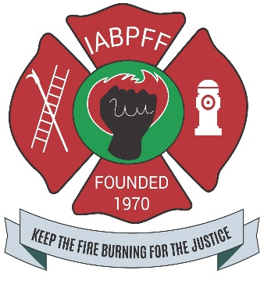
SPOUSE AGENDA
SOUTH CENTRAL REGION CONFERENCE
THURSDAY SEPTEMBER 26, 2024
10:00AM NORTH PARK MALL, SHOPPING AND PAMPERING
LUNCH AT NORTH PARK MALL
3:00PM MOVIE “THE FORGE”, AT THE STUDIO MOVIE GRILL ON ROYAL LANE AND CENTRAL EXPRESSWAY
7:00PM “MEET AND GREET” BFFA HOUSE, SNACKS
10:00PM CUNOMA….POETRY, 917 N. JOE WILSON CEDAR HILL, TX. (FREE)
FRIDAY SEPTEMBER 27, 2024
11:00AM MEMORIAL LUNCHEON AT THE ALOFT/ELEMENT HOTEL
1:00PM PAINTING WITH A TWIST EVENING
06:00PM-9:00PM FISH FRY AT 1830 PARKROW DALLAS, TX. (BFFA HOUSE)
09:00-UNTIL SANDAGA JAZZ CLUB 813 EXPOSITION DALLAS, TX.
SATURDAY SEPTEMBER 28, 2024
07:00-1200PM GOLF
11:00AM BAR-B-QUE 1830 PARKROW DALLAS, TX. (BFFA)
05:00PM PRAIRIE VIEW vs GRAMBLING GAME AND FAIR PARK
09:00-UNTIL SANDAGA JAZZ CLUB 813 EXPOSITION DALLAS, TX.
ALOFT/ELEMENT DALLAS LOVE FIELD
2333 W. MOCKINGBIRD LN. DALLAS, TX. 75235(469)466-8072

